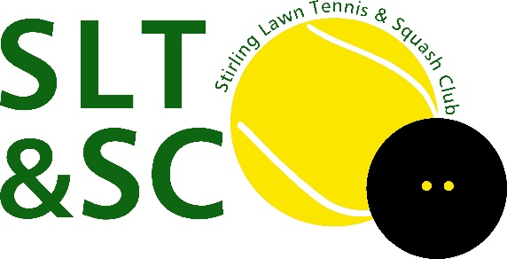
SLTSC 100-Club Sign Up

Please complete the following form and either email to Eddy Bryan at eddybryan@aol.com Or hand it to a member of the committee.
In line with GDPR, your personal data will not be shared with any other party.

Name:

Email:

Telephone:

Additional Names for each ticket purchased:

Bank account where you would like any winnings paid into:

Bank Name: _____________________________________ Sort code: ________________

Name on Account: ________________________________

Account Number: _________________

How to buy your ticket:

Please pay £20 for each entry by Bank Transfer to:

Stirling Lawn Tennis and Squash Club
Sort code: 80-91-29
Account number: 00830898
Reference: YOUR SURNAME 100-CLUB

Signature: _______________________________ Date: ----------------------------

Print name: _______________________________

